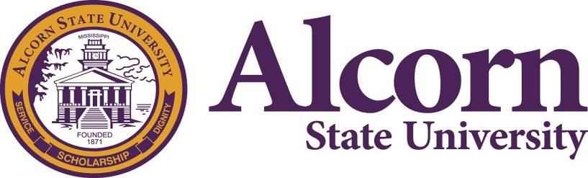 | National Alumni Association  Greater Dallas Chapter  P.O. Box 225953  Dallas, TX 75222-5953

Workshop Request
This committee would love to give the National Alumni Association a chance to suggest workshops you would like to attend. If you feel you have valuable information to share, please feel free to complete this form and present a workshop. The chairperson, Maxine Pride will contact you once a request has been made to secure the workshop presenter.

Request Guidelines
- The person making the request must be financially active in the national alumni and/or chapter alumni.
- All workshop requests must be postmarked or received by 11/30/2018 by 12am CST.
- All questions/concerns should be sent to Maxine Pride, mp70asu@yahoo.com or 214-662-4384.
- The form must be filled out completely.
- Since the number of workshops we can present are limited, the workshops will be determined on a first come first serve basis.
- Please indicate audio/visual requirements: projector, screen, microphone, wifi, etc.

Request Information
Title of Workshop:

Workshop Presenter:

Requestor Information
Requestor Name:
Chapter Name:
E-Mail Address:
Phone No:

For Committee Use Only
Date Received: |  |  | Time:
Location: |  |  | Confirmation Sent:

