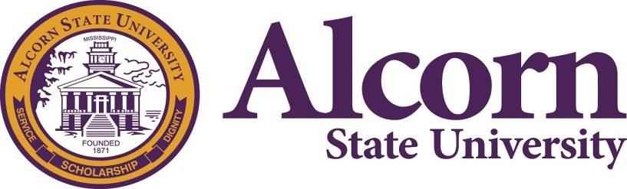 | National Alumni Association  Greater Dallas Chapter  P.O. Box 225953  Dallas, TX 75222-5953

Class/Organization Meeting Request

Request Guidelines
- The person making the request must be financially active in the national alumni and/or chapter alumni.
- The organization must be nationally recognized by the alumni association.
- All meeting requests must be postmarked or received by 11/30/2018 by 12am CST.
- All questions/concerns should be sent to Maxine Pride, mp70asu@yahoo.com 214-662-4384.
- The form must be filled out completely.
- No meeting rooms will be assigned unless a meeting request form is completed and submitted by the deadline.

Request Information
Title of Meeting:
Class or Organization (if applicable):

Requestor Information
Requestor Name:
Chapter Name:
E-Mail Address:
Phone No:

For Committee Use Only
Date Received: |  |  | Time:
Location: |  |  | Confirmation Sent:

